Smart Civic Issue Register & Tracker using Geospatial Analytics and Machine Learning
An Engineering Project in Community Service
Phase – I Report
Submitted by

Team Members List
Sl. No. | Register Number | Name
1 | 23BAI10101 | Harshit Chugh
2 | 23BAI10455 | Pratham Kashyap
3 | 23BCE10821 | Aditya Priyadarshi
4 | 23BCE10866 | Anusha Gupta
5 | 23BCE11351 | Viya Sharma
6 | 23BCY10005 | Ashwin Joseph

in partial fulfillment of the requirements for the degree of
Bachelor of Technology


VIT Bhopal University
Bhopal
Madhya Pradesh

February 2026



Bonafide Certificate

Certified that this project report titled “Smart Civic Issue Register & Tracker using Geospatial Analytics and Machine Learning” is the Bonafide work of 23BAI10101 Harshit Chugh, 23BAI10455 Pratham Kashyap, 23BCE10821 Aditya Priyadarshi, 23BCE10866 Anusha Gupta, 23BCE11351 Viya Sharma, and 23BCY10005 Ashwin Joseph who carried out the project work under my supervision.

This project report (Phase I) is submitted for the Project Viva-Voce examination held on 11^{h} February 2026.


Supervisor

Comments & Signature (Reviewer 1)

Comments & Signature (Reviewer 2)

Declaration of Originality

We, hereby declare that this report entitled "Smart Civic Issue Register & Tracker using Geospatial Analytics and Machine Learning" represents our original work carried out for the EPICS project as a student of VIT Bhopal University and, to the best of our knowledge, it contains no material previously published or written by another person, nor any material presented for the award of any other degree or diploma of VIT Bhopal University or any other institution. Works of other authors cited in this report have been duly acknowledged under the section "References".

Date: 11 February 2026

Reg No & Name
23BAI10101 - Harshit Chugh
23BAI10455 - Pratham Kashyap
23BCE10821 - Aditya Priyadarshi
23BCE10866 - Anusha Gupta
23BCE11351 - Viya Sharma
23BCY10005 - Ashwin Joseph

Acknowledgement
This work has benefited in various ways from several people. Whilst it would be simple to name them all, it would not be easy to thank them enough.
We express our sincere gratitude to Dr. Ashish Kumar Kesarwany, our project guide, for his constant guidance, valuable suggestions, and encouragement throughout the project.
We are thankful to our fellow students and batchmates for their technical discussions and moral support during the project development.
Finally, we thank our family and friends for their continuous encouragement.
Harshit Chugh
Pratham Kashyap
Aditya Priyadarshi
Anusha Gupta
Viya Sharma
Ashwin Joseph

Abstract
This report showcases the design and development of a Smart Civic Issue Register & Tracker, demonstrating the combination of machine learning and geospatial analysis techniques for civic issue handling. The system analyzes organized complaint data ranging from categories to status and geographic locations to generate analytical results through priority classification and geographic hotspot identification.

Hotspot identification is done through DBSCAN clustering, while priority prediction (LOW, MEDIUM, HIGH) is done through a Random Forest classifier with feature engineering including complaint density and resolution status. The complaint registration and tracking system is web-developed, with Firebase and Cloudinary as the backend platforms.

The project utilizes existing analytical approaches for civic issue handling by using synthetically generated but valid complaint data, providing an academic proof-of-concept for data-driven municipal decision support.

INDEX

SI.No. | Title | Page No.
1  1.1  1.2 | CHAPTER 1: Introduction  Motivation  Objectives | 9  10  11
2  2.1  2.1.1  2.1.2  2.2  2.3  2.4 | CHAPTER 2: BACKGROUND AND RELATED WORK  Analytical Techniques  Random Forest Classification  DBSCAN Clustering  Related Applications in Civic Management  Existing Civic Complaint Platforms  Identified Gap and Project Positioning | 12  12  12  12  13  13  14
3  3.1  3.2  3.3  3.3.1  3.3.2  3.3.3  3.3.4  3.3.5 | CHAPTER 3: TOPIC OF THE WORK  Overview of the Smart Civic Issue  Register & Tracker  Problem Definition  System Architecture  Architectural Overview  Data Layer  Analytical and Feature Engineering Layer  Machine Learning Layer  Visualization and Decision Support Layer | 15  15  15  16  16  16  17  17  18
4  4.1  4.1.1  4.1.2  4.1.3  4.2  4.2.1  4.2.2  4.2.2.a  4.2.2.b  4.2.2.c  4.2.3  4.2.3.a  4.2.3.b  4.2.4  4.2.5  4.3  4.4 | CHAPTER 4: SYSTEM IMPLEMENTATION & PLATFORM DESIGN  Frontend Platform Description  Web Interface Description  Complaint Registration Flow  User Dashboard Description  Backend Architecture & Implementation  Backend Overview  Firebase Backend Implementation  Firebase Authentication  Firebase Database (Firestore)  Firebase Security Rules  Image Storage Using Cloudinary  Image Upload Process  Advantages of Using Cloudinary  Backend Data Flow  Backend Benefits  Technology Stack  Visuals of Urban Civic | 20  20  20  20  21  22  22  22  22  23  23  24  24  24  24  25  25  26
5  5.1  5.2  5.2.1  5.2.2 | CHAPTER 5: WORKING PRINCIPLE  System Workflow Overview  Complaint Data Processing Workflow  Priority Classification Process  Hotspot Identification Process | 31  31  34  35  35
6  6.1  6.2  6.3 | CHAPTER 6: DATASET & EXPERIMENTAL SETUP  Dataset Characteristics  Priority Label Generation  Experimental Setup | 36  36  37  37
7  7.1  7.2  7.3  7.4  7.5 | CHAPTER 7: RESULTS & DISCUSSION  Spatial Analysis Results  Priority Classification Results  Classification Model Performance  Discussion  Concluding Insight | 38  38  40  41  42  43
8  8.1  8.2  8.3  8.4  8.5  8.6 | CHAPTER 8: INDIVIDUAL CONTRIBUTIONS  Harshit Chugh  Pratham Kashyap  Aditya Priyadarshi  Anusha Gupta  Viya Sharma  Ashwin Joseph | 45  45  45  46  46  47  47
9 | CHAPTER 9: CONCLUSION AND FUTURE WORK | 48
10 | REFERENCES | 51

1. INTRODUCTION
Rapid urbanization has increased the complexity of managing civic infrastructure in modern cities [1]. Municipal authorities are responsible for handling a wide range of public service issues, including waste accumulation, damaged roads, water leakage, drainage failures, and malfunctioning utilities. With the growing number of citizen complaints, limited administrative resources often result to delayed responses, inefficient prioritization, and ineffective allocation of municipal services [3].
Digital civic complaint platforms have improved accessibility and transparency by allowing citizens to report issues in a structured and convenient manner [2]. However, most existing systems mainly focus on complaint registration, routing, and basic status tracking. Complaints are typically treated as individual cases, with limited consideration of recurring problems, spatial concentration of issues, or relative urgency. As a result, decision-making in many cases remains reactive and dependent on manual judgment [3].
The increasing availability of structured civic complaint data provides an opportunity to support more informed and proactive governance [26,27]. Complaint records typically include information such as issue category, geographic location, timestamp, and resolution status, which are suitable for analytical processing [29]. However, without integrated analytical frameworks, this data provides limited insight into identifying hotspot regions, persistent problem areas, or effective prioritization among complaints [31].
To address this gap, the Smart Civic Issue Register & Tracker (Urban Civic) is proposed as a data-driven analytical platform that integrates machine learning based complaint prioritization with geospatial analysis [7]. The system converts structured complaint data into actionable outputs such as priority levels, heatmaps, and spatial hotspot clusters [30]. By using established and interpretable analytical techniques, the project demonstrates how an integrated ML–GIS workflow can enhance decision making in civic issue management beyond conventional reporting systems [1,3].

1.1 Motivation
The motivation for this project arises from the practical challenges faced by municipal authorities in managing civic issues in rapidly growing urban environments [1, 26]. Urban local bodies receive a large volume of complaints related to recurring infrastructure problems, many of which originate from the same localities [3]. When complaints are processed individually using mostly manual procedures, it becomes difficult to identify broader trends and high-impact areas, especially under constraints of limited time, manpower, and resources [7]. This often results in delayed responses and inefficient use of municipal infrastructure [3].
Another key motivation is the lack of systematic spatial analysis and objective prioritization in conventional complaint management systems [31]. Complaints are usually addressed without sufficient consideration of their geographic context or cumulative impact [6, 29]. This leads to repeated reporting from nearby areas and delayed attention to severely affected regions [3]. In addition, urgency is often determined using manual judgment or simple rule-based methods, which may not accurately reflect real-world severity [11]. Integrating geospatial analysis with interpretable machine learning models enables spatial patterns and contextual factors to be included in the prioritization process, supporting more consistent, transparent, and data-driven decision-making [7, 33].

1.2 Objective
The primary objective of the Smart Civic Issue Register & Tracker is to design and demonstrate a data-driven analytical framework that supports transparent and informed management of civic complaints using established machine learning and geospatial analysis techniques [1, 7, 29].
The specific objectives of the project are as follows:
- To analyze the spatial distribution of civic complaints using geospatial visualization techniques such as heatmaps and density-based clustering [5, 6, 30, 31].
- To classify civic complaints into priority levels (LOW, MEDIUM, and HIGH) using interpretable machine learning models based on engineered features [4, 8, 11, 33].
- To design a feature engineering pipeline that captures spatial, categorical, and status-related attributes relevant to civic issue prioritization [13, 19, 29].
- To support visualization-based decision making by allowing authorities to interact through an intuitive web-based interface displaying complaint patterns and hotspot regions [2, 30, 31].
- To evaluate model behavior and limitations using suitable evaluation metrics and analytical visualizations [11, 12, 33].
- To establish a scalable analytical framework that can be extended to real-world municipal data and future operational deployment [3, 7, 26].

2. BACKGROUND AND RELATED WORK
This section discusses the background concepts relevant to the Smart Civic Issue Register & Tracker and reviews related applications of data analytics and machine learning in civic issue management [7, 29]. The focus is on commonly used analytical techniques and existing civic reporting platforms that influence the design of this project [1, 3].

2.1 Analytical Techniques
The Smart Civic Issue Register & Tracker employs two widely used analytical techniques: machine learning based classification for complaint priority estimation and clustering for identifying spatial complaint hotspots [11, 19, 29].

Random Forest Classification
Random Forest, introduced by Breiman (2001) [4], is an ensemble learning method that combines multiple decision trees to improve prediction of accuracy and robustness [11, 12]. In this project, it is used to classify civic complaints into priority levels. The model can handle both numerical and categorical features, is resistant to overfitting, and provides feature importance scores that support interpretability [4, 13, 33].
These characteristics make Random Forest suitable for civic applications where reliability and explainability are important [7, 33, 34]. Similar classification approaches have been applied in urban analytics and municipal service management systems [8, 29].

DBSCAN Clustering
DBSCAN (Density-Based Spatial Clustering of Applications with Noise), proposed by Ester et al. (1996) [5], is a density-based clustering algorithm that groups data points based on spatial proximity [20]. Unlike partition-based methods, DBSCAN does not require the number of clusters to be predefined and can identify irregularly shaped clusters while treating isolated points as noise [5, 21].
In civic complaint analysis, DBSCAN is effective because complaints are often unevenly distributed across geographic regions [6, 29, 31]. Its ability to detect dense complaint zones while separating isolated incidents makes it suitable for identifying civic issues of hotspots [5, 6, 30].

2.2 Related Applications in Civic Management
Digital civic complaint management systems are widely used to handle issues such as solid waste accumulation, water leakage, potholes, and streetlight failures [1, 3, 29]. Municipal platforms collect structured complaint data including issue category, geographic location, reporting time, frequency, and resolution status [29, 31].
Previous studies indicate that such data is suitable for machine learning based classification and priority estimation, which can reduce manual effort and improve operational efficiency [7, 8, 11].
For waste management and water leakage, repeated complaints from the same locations often indicate persistent infrastructure problems rather than isolated incidents [3, 29]. Data-driven analysis helps identify high-risk zones and supports proactive maintenance planning [26, 27].
Spatial clustering techniques have also been applied to analyze complaints related to road damage and streetlight failures, where multiple reports often originate from nearby locations [5, 6, 20]. These approaches assist in identifying problem zones and enable targeted resource allocation [3, 7, 31]. However, most deployed systems still function primarily as reporting tools with limited integration of analytical decision support [3, 7].

2.3 Existing Civic Complaint Platforms
Several digital platforms enable citizens to report civic issues and track their resolutions [2, 3]. Systems such as FixMyStreet (UK), SeeClickFix (USA), and municipal 311 services provide map-based reporting, automated routing, and basic status updates [2, 30, 31].
In India, platforms such as the Swachhata MoHUA application under the Swachh Bharat Mission allow citizens to submit GPS-enabled and image-based complaints related to sanitation services [32]. While these platforms have improved accessibility and transparency, advanced analytical capabilities such as machine learning–based prioritization and spatial hotspot detection are generally not integrated into routine workflows [3, 7].
Commercial platforms like Catalis Request311 further extend these capabilities by offering structured request management, dashboards, and GIS-based visualization to support municipal workflows [30, 31].

2.4 Identified Gap and Project Positioning
The review of existing literature and deployed platforms reveals a gap between analytical methods explored in research and their implementation in real-world civic systems [3, 7]. While prior studies demonstrate the usefulness of machine learning and GIS techniques, these methods are often applied independently or evaluated on static datasets [8, 11, 29, 31]. In contrast, most operational systems focus mainly on complaint registration and tracking, with limited integration of data-driven prioritization or spatial decision support into routine workflows [2, 3, 7].
The Smart Civic Issue Register & Tracker addresses this gap by integrating interpretable machine learning and spatial clustering into a unified analytical workflow [5, 7, 33]. The project focuses on combining existing methods rather than proposing new algorithms and demonstrates the approach using synthetic yet realistic data to ensure reproducibility and transparency [11, 19].
This positioning allows the work to serve as a proof-of-concept framework that bridges academic research and practical civic analytics, highlighting how integrated ML–GIS approaches can enhance data-driven decision support in urban service management [1, 3, 7, 29, 31].

3. TOPIC OF THE WORK
3.1 Overview of the Smart Civic Issue Register & Tracker
The Smart Civic Issue Register & Tracker is a data driven decision support system developed to assist municipal authorities in managing civic complaints more effectively. The system aims to transform structured complaint data into meaningful insights that support systematic prioritization and improved understanding of spatial patterns in urban service issues, without replacing human decision-making.
The platform operates on structured civic complaint records that include geographic coordinates, issue categories, timestamps, and resolution status. Based on this information, the system derives additional features such as complaint density and recurrence indicators. These features are used for priority classification and spatial pattern analysis. The generated insights are presented through visual tools such as heatmaps and spatial clusters, enabling authorities to interpret complaint trends and identify high-impact regions in a clear and transparent manner.

3.2 Problem Definition
Urban local bodies regularly receive a large number of civic complaints related to infrastructure services such as waste management, road maintenance, water leakage, drainage systems, and streetlight failures. In existing systems, these complaints are mostly handled individually, with limited use of historical data and minimal consideration of spatial distribution or recurring patterns across locations.
As a result, complaint handling often depends on manual judgment, where urgency is assessed without systematically accounting for factors such as complaint density, spatial clustering, or occurrence frequency. This limits early identification of severely affected regions, leads to inefficient allocation of field resources, and reduces the ability to use historical complaint data for proactive planning.
The Smart Civic Issue Register & Tracker addresses this operational limitation by introducing a data-driven framework that integrates complaint prioritization with spatial pattern analysis. By converting routine complaint records into structured spatial and priority-based insights, the system supports more consistent, transparent, and informed decision-making within existing civic management processes.

3.3 System Architecture
3.3.1 Architectural Overview
The Smart Civic Issue Register & Tracker follows a modular, data-driven system architecture designed to transform structured civic complaint data into actionable decision-support insights. The architecture is organized into logically separated layers to ensure that data collection, processing, learning, and visualization are functionally independent while remaining seamlessly integrated.
The system is divided into four major layers:
- Data Layer (Input & Storage)
- Analytics & Feature Engineering Layer
- Machine Learning Layer
- Visualization & Decision Support Layer
Each layer plays a specific role in converting raw complaint records into spatial and priority-based insights that assist authorities in managing civic issues more effectively.

3.3.2 Data Layer
The Data Layer is responsible for the collection, organization, and storage of structured civic complaint data used by the system.
Input Attributes
- Complaint ID
- Issue category (garbage, pothole, water leakage, streetlight)
- Complaint description provided by the user
- Complaint status (Pending, In Progress, Resolved)
- Address or locality information
- Geographic coordinates (Latitude and Longitude)
- Image URL (Cloudinary-hosted image)
- Timestamp
For academic demonstration purposes, the system uses synthetically generated yet structurally realistic urban complaint data. The data is stored in a tabular format to support consistent, repeatable, and reproducible analytical processing.

3.3.3 Analytics and Feature Engineering Layer
Individual complaint records provide limited insight into civic urgency or spatial relevance when analyzed in isolation. The Analytics and Feature Engineering Layer enhances the usefulness of the data by converting basic complaint attributes into higher-level features that better reflect real-world civic conditions.
Generated Features include:
- Complaint Density Score, representing localized concentrations of complaints
- Category Frequency, indicating repeated occurrences of specific issue types
- Pending Status Indicator, highlighting unresolved complaints
- Risk Signal Score, combining multiple factors to estimate overall complaint urgency

This transformation enables raw data to be converted into meaningful analytical inputs that can be effectively used for learning, pattern discovery, and decision-making.

3.3.4 Machine Learning Layer
The Machine Learning Layer applies established analytical models to extract patterns and generate interpretable insights from the engineered features.
Priority Classification (Random Forest)
Random Forest classifier is used to estimate complaint urgency by categorizing complaints into three priority levels:
- LOW
- MEDIUM
- HIGH
The classification is based on contextual and spatial features rather than manual labeling, enabling consistent and explainable priority estimation.

Spatial Hotspot Detection (DBSCAN)
To identify geographic concentrations of civic issues, the DBSCAN clustering algorithm is applied to complaint location data. This model:
- Detects high-density complaint clusters representing areas requiring immediate attention
- Identifies isolated complaints as noise, distinguishing them from persistent problem zones
This layer transforms analytical information into higher-level intelligence that supports operational planning and intervention.

3.3.5 Visualization and Decision Support Layer
The Visualization and Decision Support Layer present analytical and machine learning outputs through an intuitive and user-friendly interface designed for administrative users.
Key visual outputs include:
- Geographic heatmaps illustrating complaint density
- Spatial cluster maps highlighting hotspot regions
- Priority distribution charts across issue categories
- Summary views of complaint status and resolution
By converting analytical insights into visual representations, this layer supports transparent, informed, and data-driven decision making within civic management workflows.

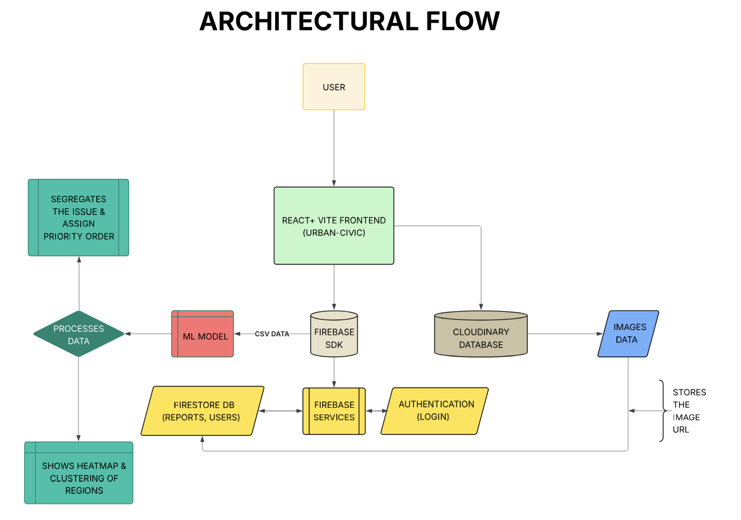Fig. 3.1: Architectural Flow of Smart Civic Issue Register & Tracker

4. SYSTEM IMPLEMENTATION & PLATFORM DESIGN
4.1 Frontend & Platform Description
4.1.1 Web Interface Description
The Urban Civic platform provides a simple, interactive, and responsive web interface for citizens to report and track civic issues efficiently. The frontend is developed using modern web technologies to ensure smooth performance, intuitive navigation, and cross-device compatibility (such as desktops, tablets, and smartphones).
The interface follows a user-centric design approach, with emphasis on clarity, accessibility, and ease of use. All essential functionalities are clearly visible and organized, allowing users to interact with the system without prior technical knowledge.
Key elements of the web interface include:
- Home page explaining the purpose and functionality of the Urban Civic platform
- Secure user registration and login system
- Complaint registration interface for submitting civic issues
- User dashboard for complaint tracking
- Profile management and logout options
The clean layout and intuitive navigation enhance overall user experience and encourage active participation from citizens in reporting civic issues.

4.1.2 Complaint Registration Flow
The complaint registration process is designed to be efficient, transparent, and easy to use. The workflow minimizes user effort while ensuring that sufficient information is collected for effective complaint processing and analysis.
Complaint Registration Process:
- User Authentication
- The user registers or logs into the platform using valid credentials through a secure firebase authentication system.

- Navigate to Complaint Section
- After successful login, the user selects the Register Complaint option from the dashboard or main menu.

- Fill Complaint Details
- The user fills a structured complaint form that includes:
  - Complaint category (e.g., waste management, water leakage, streetlight failure, pothole issues)
  - Detailed description of the issue
  - Location information
  - Optional image upload to provide visual context

- Complaint Submission
- Upon submission, the complaint is stored in the system database and assigned a unique complaint ID for reference.

- Confirmation & Tracking
- The user receives confirmation pop up and can track the complaint status through the dashboard.
This structured flow ensures transparency and allows users to monitor the progress of their complaints in real time.

4.1.3 User Dashboard Description
The user dashboard acts as the central interface for users to monitor and manage their registered complaints. It provides a clear overview of complaint history and current status.
Dashboard features include:
- List of all registered complaints
- Display of complaint status (Pending, In Progress, Resolved)
- Complaint submission history with date
- Option to view detailed information for each complaint
- Quick access to profile and logout features
The dashboard offers users real-time visibility into their complaint status, improving trust, accountability, and engagement with the civic system.
4.2 Backend Architecture & Implementation
4.2.1 Backend Overview
The backend of the Urban Civic platform is designed to manage user authentication, complaint data storage, real-time updates, and secure multimedia handling. The system is implemented using Firebase as the primary backend service and Cloudinary for image storage.
This cloud-based architecture ensures scalability, reliability, and real-time data synchronization without requiring dedicated server infrastructure and maintenance.

4.2.2 Firebase Backend Implementation
Firebase serves as the core backend service for the Urban Civic platform, providing integrated tools that simplify development and enhance performance.
4.2.2.a Firebase Authentication
Firebase Authentication is used to manage secure user access to the platform. It provides the following functionalities:
- Email-based user registration and login
- Secure authentication mechanisms
- Prevention of unauthorized access to complaint data
- Maintenance of user session state across the application
Each user is uniquely identified by a Firebase-generated user ID, which links complaint records to individual users.

4.2.2.b Firebase Database (Firestore)
Firebase Firestore is used to store and manage all complaint related data, including:
- User details (user ID, name, email)
- Complaint ID
- Complaint category and description
- Location details
- Complaint status (Pending, In Progress, Resolved)
- Timestamp of complaint submission
- Cloudinary generated image URL (if an image is uploaded)
Firestore supports real-time data synchronization, enabling users to instantly view updates to their complaint status on the dashboard.

4.2.2.c Firebase Security Rules
Firebase Security Rules are implemented to ensure data privacy and protection. These rules:
- Restrict users to access only their own complaint records
- Prevent unauthorized read and write operations
- Enforce secure communication between frontend and backend services
These measures help maintain data confidentiality, integrity, and secure platform operation.

4.2.3 Image Storage Using Cloudinary
Cloudinary is integrated into the system to handle image uploads associated with civic complaints in an efficient and scalable manner.
4.2.3.a Image Upload Process
- The user uploads an image while submitting a complaint
- The image is uploaded directly to Cloudinary
- Cloudinary processes and securely stores the image
- A unique image URL is generated
- The URL is stored in Firebase alongside complaint data
This approach reduces storage load on Firebase and improves overall system performance.
4.2.3.b Advantages of Using Cloudinary
- Secure and scalable cloud-based storage for images
- Automatic image optimization and compression
- Fast image delivery through CDN
- Support for multiple image formats
- Reduces backend storage overhead
4.2.4 Backend Data Flow
The backend data flow in Urban Civic follows a structured and secure process:
- User interactions on the frontend trigger backend services.
- Authentication is verified using Firebase Authentication.
- Complaint data is stored or retrieved from Firestore.
- Images are stored in Cloudinary with URLs linked to complaint records in Firestore.
- Complaint status updates are reflected in real time on the user's dashboard.
This seamless interaction between Firebase and Cloudinary ensures efficient and reliable backend operations.

4.2.5 Backend Benefits
The Firebase and Cloudinary-based backend architecture offers several advantages:
- Serverless architecture reduces maintenance complexity
- High scalability for large user bases
- Real-time complaint tracking and updates
- Secure authentication and controlled data access
- Efficient handling of multimedia content.
4.3 Technology Stack

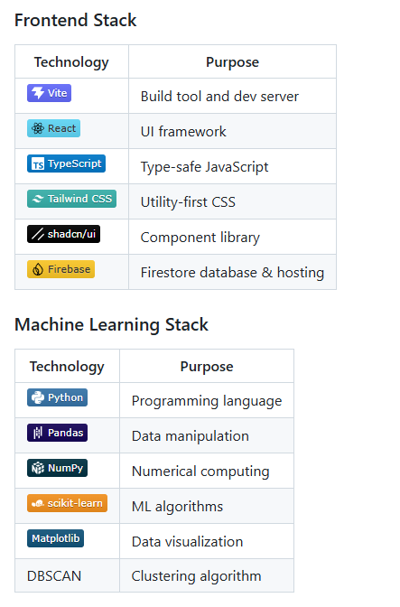
Fig. 4.1: Technology Stack
4.4 Visuals of Urban Civic
Fig. 4.2: Opening of Site
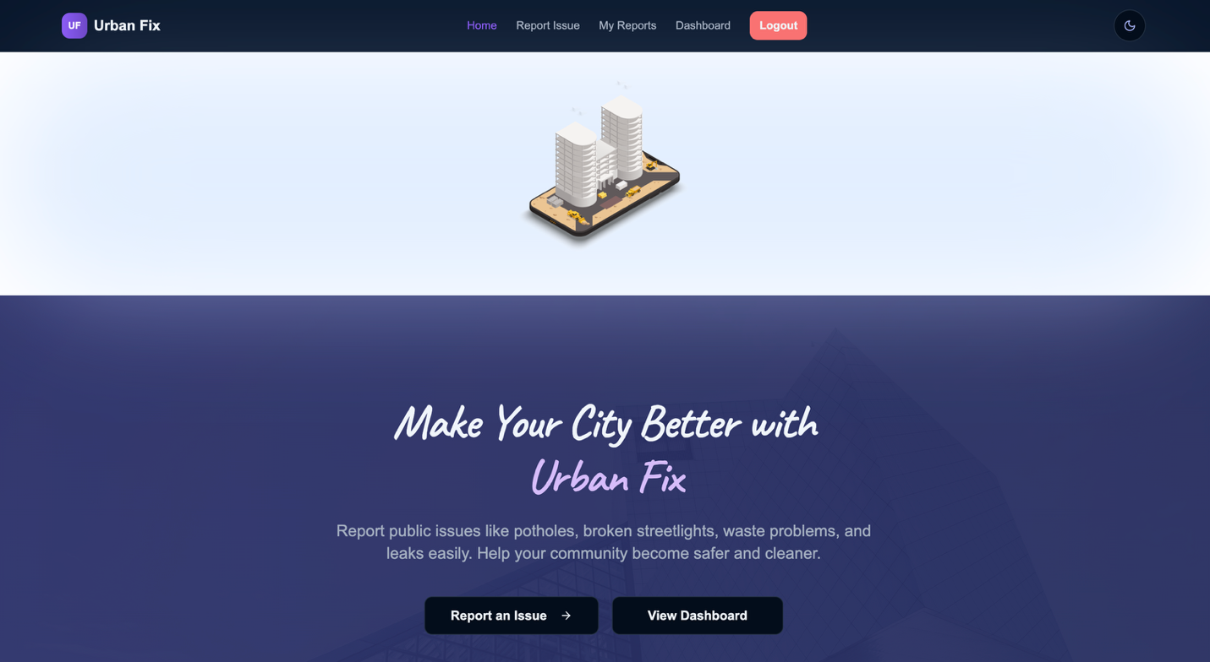Fig. 4.3: Home Page
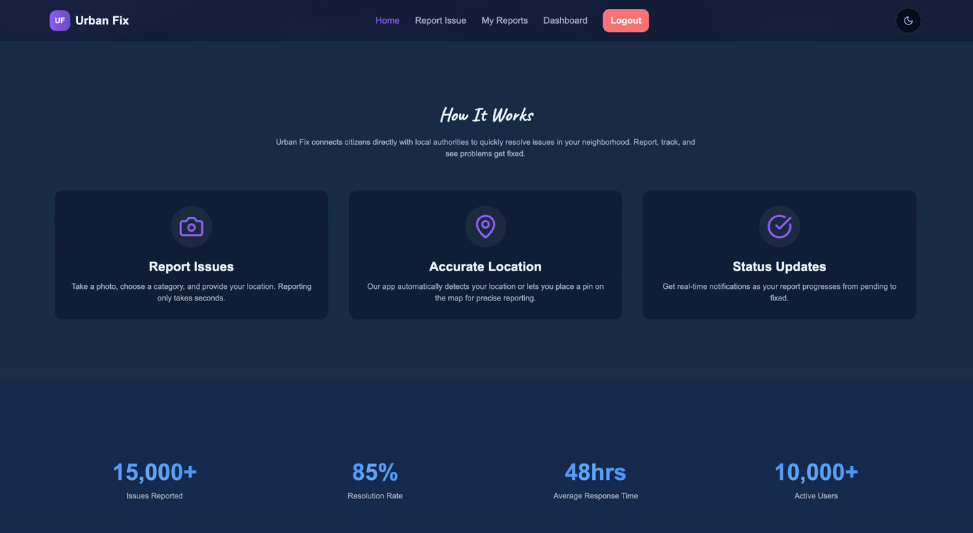Fig. 4.4: Guidelines and Working

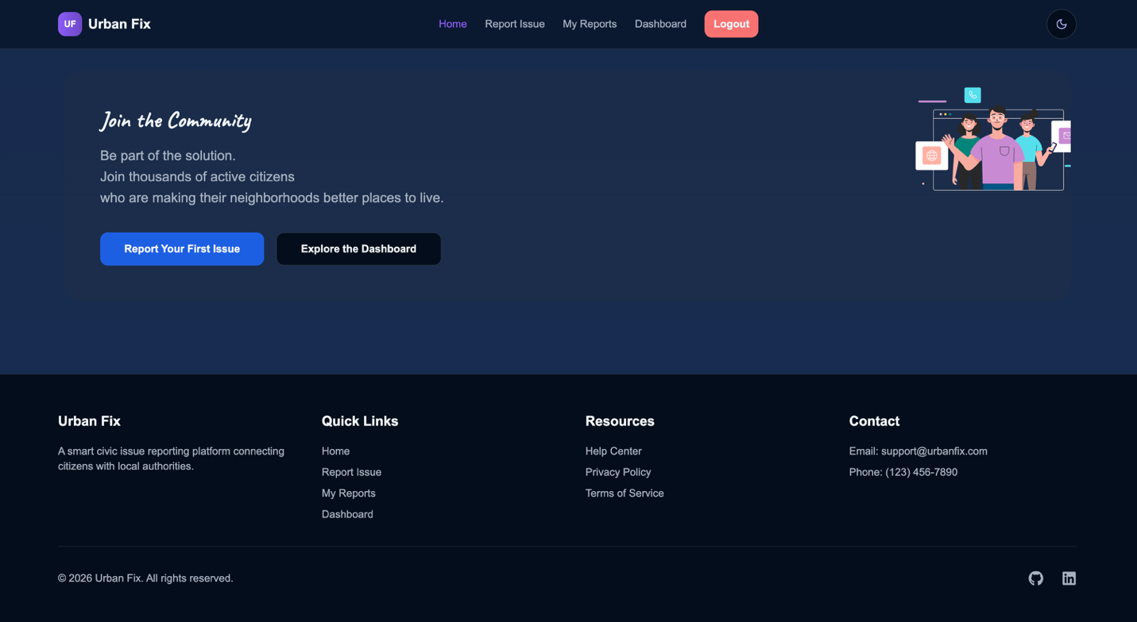Fig. 4.5: Join our community
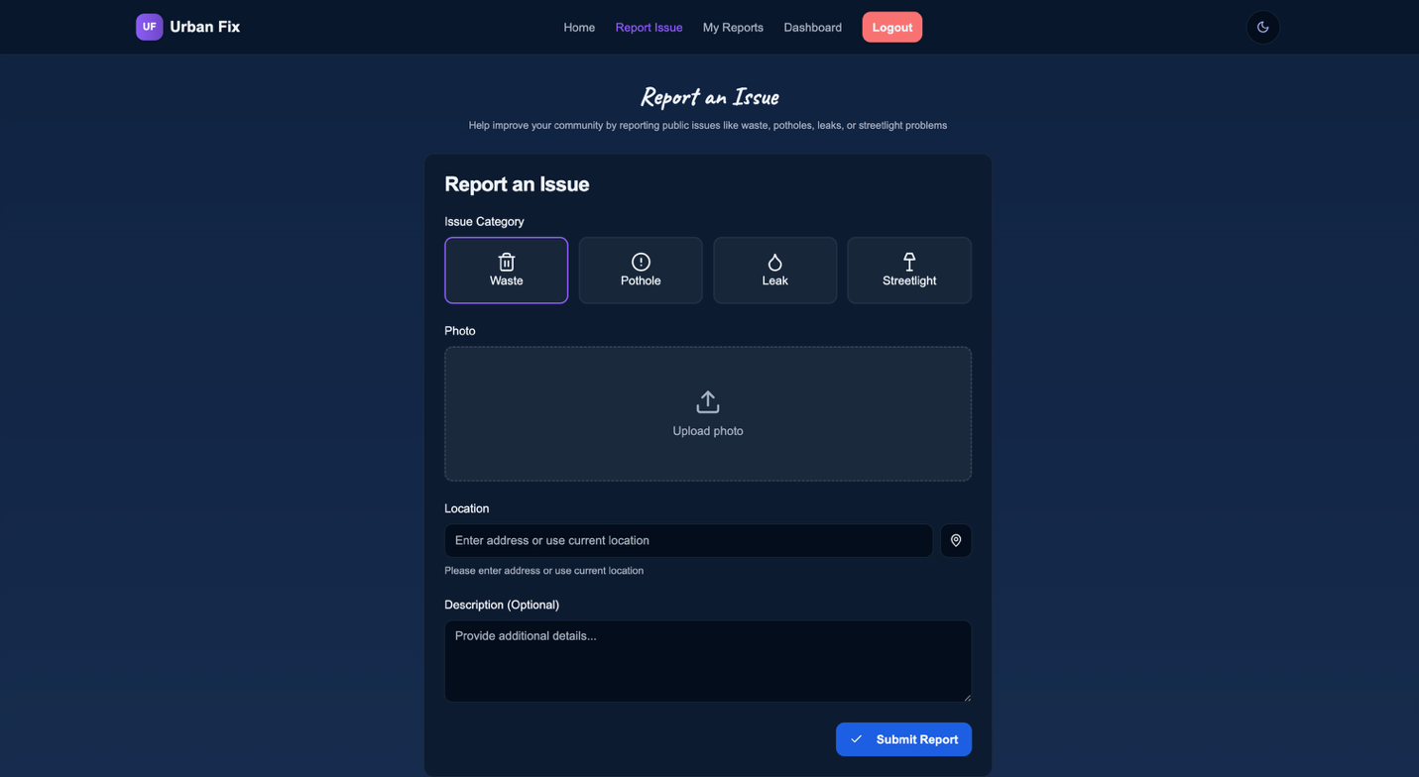Fig. 4.6: Reporting an issue
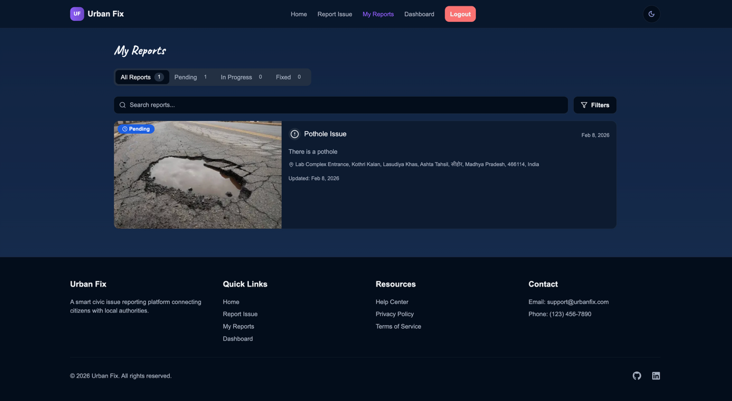Fig. 4.7: User Report Section
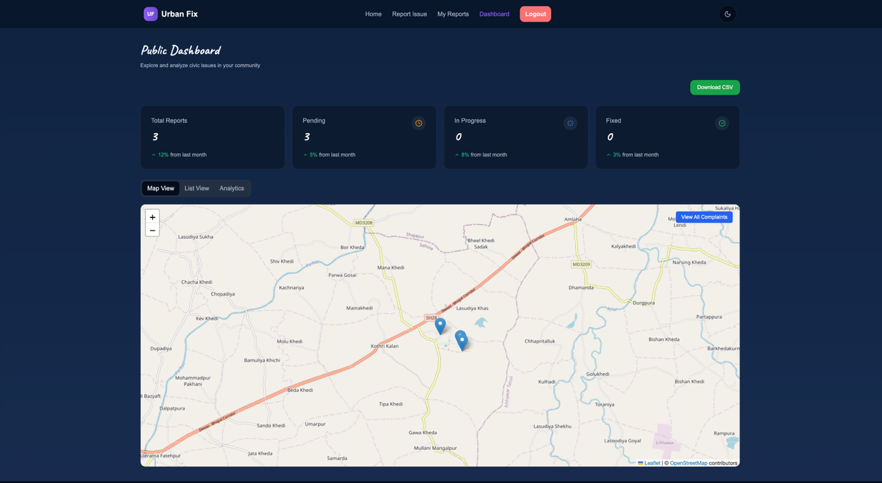Fig. 4.8: User Dashboard

Fig. 4.9: Help Centre Page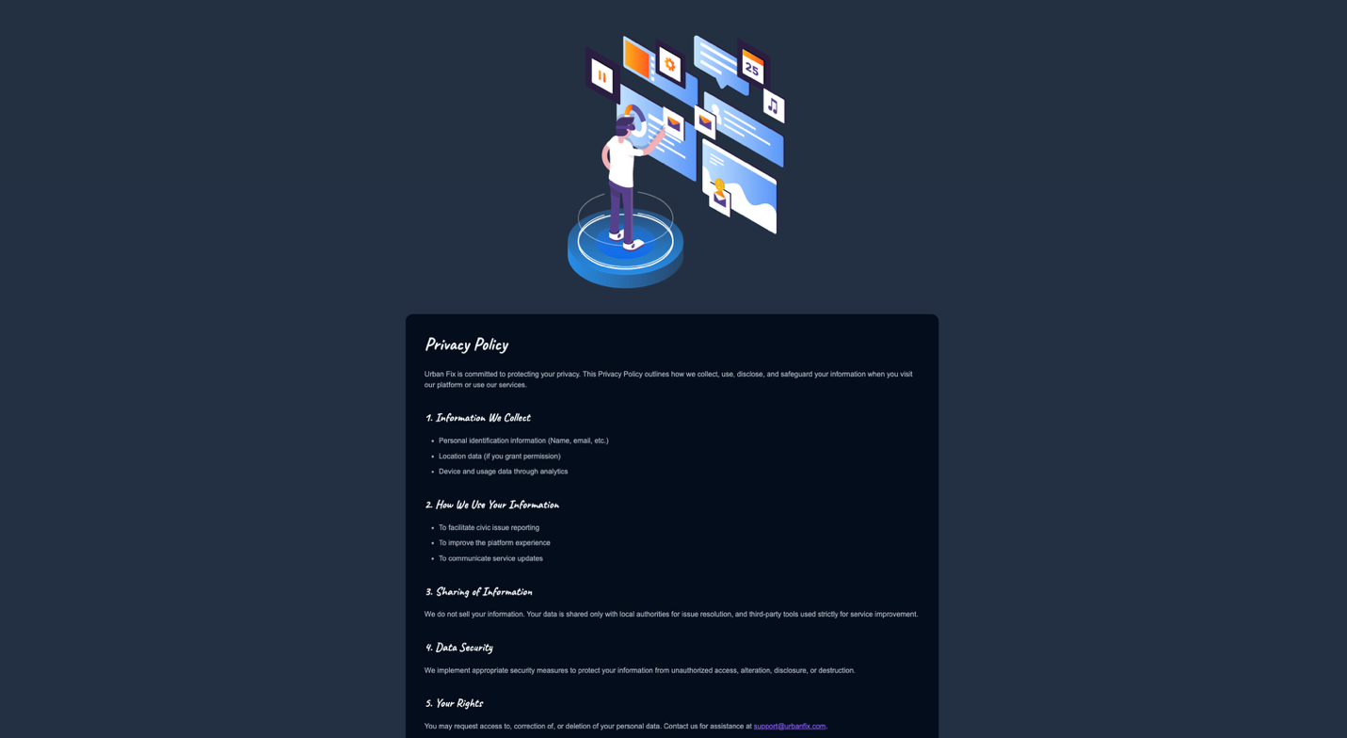Fig. 4.10: Privacy Policy Page

Fig. 4.11: Terms of Service Page
5. WORKING PRINCIPLE
The Smart Civic Issue Register & Tracker operates as a structured and data driven workflow that transforms individual civic complaints into actionable decision-support insights for municipal authorities. Instead of relying solely on manual judgment, the system integrates spatial analysis and machine learning to support consistent and informed decision-making.

5.1 System Workflow Overview
The overall system workflow consists of the following stages:
- Registration of a civic complaint by a citizen
- Validation and storage of complaint data
- Computation of analytical and contextual features
- Prediction of complaint priority using a machine learning model
- Detection of spatial hotspots using clustering techniques
- Visualization of results through an administrative dashboard
- Resource allocation and intervention based on generated insights

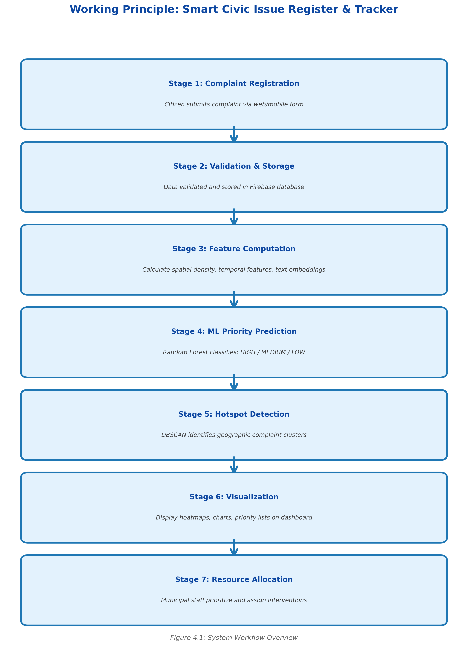
Fig. 5.1: System Workflow

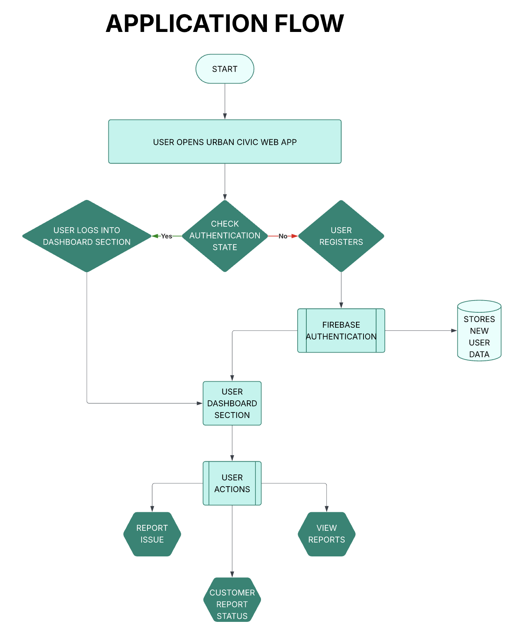
Fig. 5.2: Application Flow of Smart Civic Issue Register & Tracker
5.2 Complaint Data Processing Workflow
The workflow begins when a citizen registers a civic issue through the platform. Each complaint enters the system as a structured record containing essential attributes such as issue category, geographic location, and status.
Stage 1: Compliant Entry
For example, a citizen reports a pothole at a specific geographic location. At this stage, the complaint contains only raw information, including:
- Issue category: Pothole
- Location: (Latitude, Longitude)
- Status: Pending

Stage 2: Feature Transformation
The system computes contextual and spatial indicators that reflect surrounding civic conditions. These derived features include:
- Number of nearby complaints
- Frequency of the same issue category in the surrounding area
- Presence of unresolved complaints
Based on these factors, the system estimates the urgency of the complaint.

Stage 3: Machine Learning Analysis
The transformed data is processed using a Random Forest model to predict the complaint’s priority level (LOW, MEDIUM, or HIGH). In parallel, the DBSCAN clustering algorithm analyzes geographic proximity to determine whether the complaint belongs to a spatial hotspot.

Stage 4: Dashboard Output
The results are displayed through a visual dashboard highlighting:
- High-priority complaints
- Spatial hotspot regions
- Recurring infrastructure issues
This enables administrators to quickly identify critical areas and recurring problems requiring attention.
5.2.1 Priority Classification Process
The priority classification process assigns a priority level to each complaint based on multiple contextual and spatial factors rather than a single attribute. By considering factors such as complaint density, recurrence, and resolution status, the system is able to distinguish between isolated complaints and recurring high-risk issues. This supports more consistent and objective prioritization compared to manual assessment.
5.2.2 Hotspot Identification Process
The hotspot identification process focuses on detecting geographic regions with a high concentration of civic complaints. Using the DBSCAN clustering algorithm, complaints are grouped based on spatial density. This allows the system to identify persistent problem zones while separating isolated cases. The resulting hotspot regions help administrators recognize areas that require immediate attention and targeted intervention.
6. DATASET & EXPERIMENTAL SETUP
6.1 Dataset Characteristics
The experiments were carried out using a civic complaint dataset that was synthetically generated to represent real-world complaint patterns in urban areas. The dataset consists of 1,600 civic complaints from 42 distinct geographic locations. Duplicate complaint analysis revealed that there is only one duplicate complaint pair, and 127 complaints have recurring issues, which represent complaints from the same locations.
The dataset consists of five categories of complaints, which are distributed as follows:
- Waste: 497 complaints (31.06%)
- Potholes: 425 complaints (26.56%)
- Streetlight: 311 complaints (19.44%)
- Drainage: 214 complaints (13.38%)
- Water Supply: 153 complaints (9.56%)
The distribution of the complaints represents typical civic complaints in urban areas, with waste and road complaints making up the majority.
The status of the complaints is distributed as follows:
- Pending: 757 complaints (47.31%)
- Completed: 713 complaints (44.56%)
- Cancelled: 130 complaints (8.12%)
The high number of pending complaints was introduced to enable prioritization and risk analysis.

6.2 Priority Label Generation
The priority labels of the complaints were generated using a deterministic rule-based approach based on an engineered risk signal. The risk signal is a combination of spatial density and complaint status information:
Risk Signal=0.6×Density Score+0.4×Is Pending
Based on this, priorities were assigned using fixed thresholds:
- HIGH (2): Risk Signal ≥ 0.7
- MEDIUM (1): Risk Signal ≥ 0.4
- LOW (0): Risk Signal < 0.4
The class distribution is:
- LOW: 841 complaints (52.56%)
- MEDIUM: 729 complaints (45.56%)
- HIGH: 30 complaints (1.88%)
The percentage of HIGH priority complaints is low as it is realistic to assume that critical complaints are not as common but still need to be focused on.

6.3 Experimental Setup
Experiments for priority classification were done using Decision Tree and Random Forest classifiers. A Decision Tree classifier with a maximum depth of 4 was compared in two settings: test size = 0.2 and test size = 0.25 with stratified sampling. A Random Forest classifier with 150 trees and a maximum depth of 6 was compared using stratified sampling.

Hotspot identification was done using the DBSCAN clustering algorithm with parameters eps = 0.002 and min_samples = 3, chosen after exploratory analysis of complaint density and geographical separation.

7. RESULTS AND DISCUSSION
7.1 Spatial Analysis Results
Density-based clustering algorithms and geographic heatmaps were used to analyze the spatial distribution of municipal complaints. It is simple to identify the parts of the city that commonly deal with complaints like potholes, drainage problems, and garbage disposal by looking at the geographic heatmap, which shows the locations of high-density complaint areas.
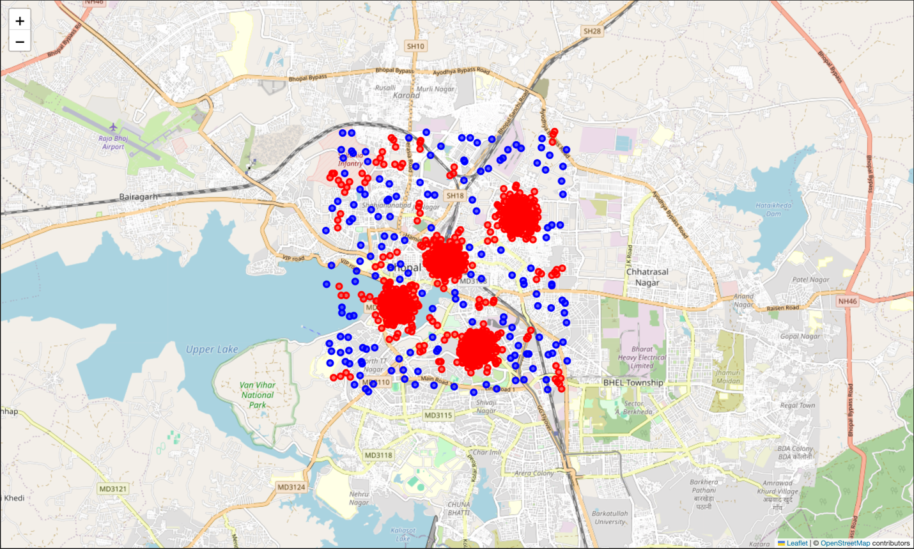
Fig. 7.1: Geographic Heatmap of Civic Complaints
Additionally, the DBSCAN-based hotspot detection method found multiple clusters of dense spatial locations, supporting the notion that the distribution of complaints is not uniform. Clustering makes sense when considering real or imagined trends in the number of service requests that take place in a city. Using the potential advantages of geographic data analytics, the workflow is validated by the presence of clustering.
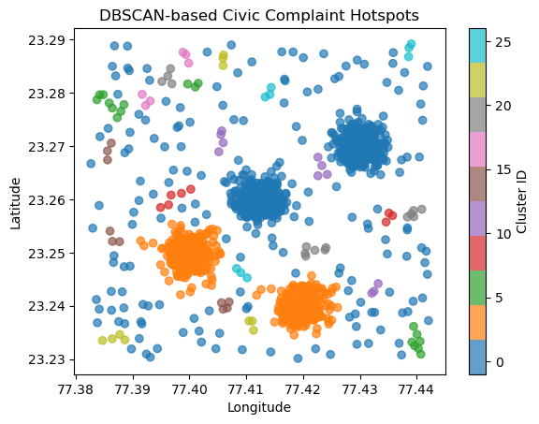
Fig. 7.2: DBSCAN-Based Spatial Clustering of Civic Complaint Hotspots

7.2 Priority Classification Results
An engineering risk-signal-based rule was used to construct priority labels, and this mapping was then taught Random Forest and Decision Tree classifiers.

Priority Level | Number of Complaints | Percentage
LOW | 841 | 52.56%
MEDIUM | 729 | 45.56%
HIGH | 30 | 1.88%
Table 7.1: Distribution of Complaint Priority Levels
According to the distribution, which reflects actual urban service-request patterns, critical concerns are comparatively uncommon, whereas the majority of civic issues fall into categories of controllable urgency.
Model | Accuracy | Precision | Recall | F1-Score
Decision Tree (depth = 4) | 1.00 | 1.00 | 1.00 | 1.00
Random Forest (150 trees, depth = 6) | 1.00 | 1.00 | 1.00 | 1.00
Table 7.2: Classification Model Performance Comparison

Both classifiers consistently learned the deterministic priority-labeling logic, achieving flawless prediction performance.

7.3 Classification Model Performance
Decision Tree and Random Forest models trained on artificial analytical features were used in priority classification tests. With precision, recall, and F1 scores of 1.00 for every priority class, both models attained 100% accuracy.
Under various evaluation conditions, the Decision Tree classifier showed perfect separation of LOW, MEDIUM, and HIGH priority complaints, suggesting that the learnt decision boundaries closely resemble the underlying priority-labeling logic. Consistent and steady learning behavior across ensemble-based predictions was also confirmed by the Random Forest model, which generated identical performance metrics.

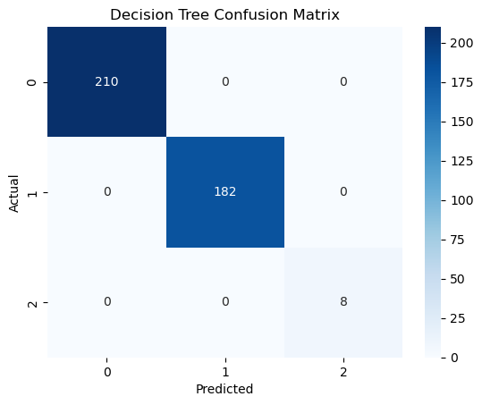
Fig. 7.3: Confusion Matrix of Priority Classification
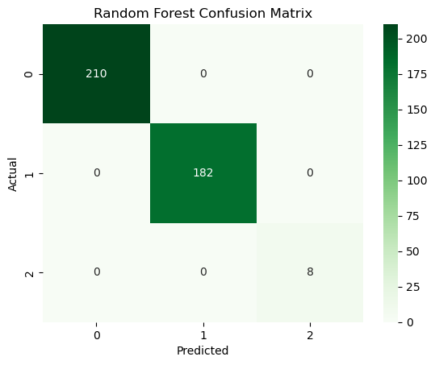
Fig. 7.4: Feature Importance in Random Forest Model

7.4 Discussion
The experimental findings demonstrate that combining machine learning-based prioritization with geospatial analytics yields significantly more insightful results than handling civic complaints as separate documents. While classification techniques convert contextual complaint attributes into interpretable urgency levels, spatial clustering makes it possible to identify recurrent problem zones. These analytical elements work together to create a logical decision-support pipeline that is appropriate for the examination of civic data.
It is important to exercise caution when interpreting the reported 100% classification accuracy. In this study, a deterministic rule-based risk-scoring mechanism based on the same engineering characteristics utilized for model training was applied to generate priority labels. As a result, rather than uncovering undiscovered real-world patterns, the machine-learning models successfully mastered a predetermined decision rule. The purpose of this experimental design was to:
- Verify that feature engineering is accurate.
- Show how to integrate machine learning components from beginning to end.
- Maintain the decision logic's interpretability and transparency.
Classification performance will be predicted to fluctuate and probably decline in real city deployments when complaints of priority are dependent on subjective administrative judgement, insufficient information, and dynamic environmental conditions.
The usefulness of spatial analytics in municipal government is further supported by the DBSCAN hotspot detection results. Authorities can differentiate between individual instances and systematic regional issues by identifying dense complaint clusters and separating noise locations. Actionable indications for setting priorities for field interventions are provided by cluster-level information, such as the number of complaints, density score, and pending-complaint ratio.
Even with these encouraging analytical results, there are still a few restrictions:
- Instead of using actual municipal complaint data, the study uses a synthetic dataset.
- There is no modelling of live operating restrictions or temporal dynamics.
- Currently, the system exhibits analytical viability rather than deployment that is suitable for production.
Future research will concentrate on temporal trend modelling, integrating real civic statistics, enabling live inference, and verifying model behavior under actual administrative decision-making procedures.
7.5 Concluding Insight
Overall, the results confirm that the proposed Smart Civic Issue Register & Tracker:
- It effectively integrates feature engineering with machine learning and geospatial analytics.
- Produces readable and logically consistent analytical output.
- Demonstrates an illustrative academic structure that is already applicable for expansion towards real world civic data deployment.
It hence validates the feasibility of a data-driven analysis of civic complaints while establishing a scalable analytic foundation for future decision-support applications in municipalities.

8. INDIVIDUAL CONTRIBUTION OF TEAM MEMBERS


8.1 Harshit Chugh (23BAI10101)
- Designed and documented the system architecture
With clear data flow.
- Organized the project into four layers data, features,
ML visualization.
- Defined the complaint data processing workflow.
- Built features for density and risk scoring.
- Helped estimate complaint priority automatically.


8.2 Pratham Kashyap (23BAI10455)
- Designed and implemented the core analytical pipeline
for the project
- Developed feature engineering and priority classification logic
- Applied machine learning models for complaint prioritization
and hotspot analysis
- Integrated analytical outputs with visualizations and supported
report documentation

8.3 Aditya Priyadarshi (23BCE10821)

- Managed the project repository structure and version control
using Git and GitHub.
- Assisted in frontend and backend integration planning for the
Urban Civic dashboard.
- Supported data handling workflows between the ML pipelines
and the web interface
- Helped coordinate code updates and resolve merge and
Repository consistency issues
- Contributed to ensuring smooth collaboration between
Analytics and frontend components

8.4 Anusha Gupta (23BCE10866)

- Assisted in exploratory data analysis of civic complaint datasets
- Supported preparation and verification of visualization outputs for
clustering and classification results
- Helped review analytical results for correctness and interpretability
- Contributed to report formatting, figure placement, and consistency
checks
- Assisted in refining explanations of results and discussion sections

8.5 Viya Sharma (23BCE11351)

- Assisted in experimentation with priority classification
models
- Supported validation of classification outputs and comparison
of model behavior
- Helped refine analytical outputs such as confusion matrices
and feature importance plots
- Contributed to improving clarity in result interpretation
and documentation
- Assisted in reviewing notebook outputs for consistency
and reproducibility


8.6 Ashwin Joseph (23BCY10005)
- Assisted extensively in documentation preparation and
report structuring
- Helped review and proofread analytical sections for clarity
and coherence
- Supported formatting of figures, tables, and section layouts
as per EPICS guidelines
- Assisted in organizing report content and ensuring
consistency across chapters
- Contributed to final compilation and quality checks before
Submission

9. CONCLUSION AND FUTURE WORK
9.1 Conclusion
This project has been about the design and development of the Smart Civic Issue Register & Tracker as a data-driven analytical approach for civic complaint management. The main aim was not to develop an alternative to existing city-level platforms but to show how machine learning and geospatial analysis can be systematically combined to facilitate data-driven decision-making in civic administration.
The system has successfully converted civic complaint data into analytical insights using two major components:
(i) priority classification with an interpretable Random Forest model, and
(ii) spatial hotspot detection with DBSCAN clustering.
By using engineered features like complaint density, category distribution, and resolution status, the system has gone beyond individual civic complaint management and enabled analysis of frequent issues and high-impact areas.
The experimental results have confirmed the analytical process. The spatial heatmaps and clustering results have shown evident non-uniform distributions of complaints, proving the existence of local hotspots for civic issues. The priority classification models have shown perfect accuracy on the experimental data, which is expected due to the deterministic nature of the engineered labeling approach. Although this accuracy does not reflect real-world predictive performance, it has confirmed the correctness, consistency, and interpretability of the feature engineering and model integration process.
One of the major contributions of this work is the clear and modular system design, which distinctly divides data processing, feature engineering, machine learning, and visualization modules. This design improves reproducibility, interpretability, and extensibility, which are highly desirable properties for civic analytics systems functioning in public sector settings.
In conclusion, this project has successfully demonstrated the feasibility and utility of a data-driven analytical approach for civic complaint management. It has provided a strong academic basis for incorporating ML-GIS workflows into city-level decision-support systems and has shown how existing analytical tools can be effectively combined to improve civic governance.

9.2 Future Work
The present structure indicates that analysis is conceivable, though there are a few obvious steps to make it more sensible, flexible, and applicable in real life:
1) Bring in actual municipal data
Future work could involve using the system on actual complaint records in a city. This would help real-world messiness data that is missing or wrong, subjective prioritization of results, and biases in the reporting to test the system.
2) Add time, trends, and patterns
Currently, the emphasis is on where and what, rather than when. The inclusion of the "when" factors, such as the dynamics of the issue over time, seasonal variations, and escalation, could be beneficial for the proactive formulation of plans concerning the rise of issues in the community.
3) Enable live inference and dashboards
Also, making this framework amenable to live updates should permit priorities and hotspot labels to change due to new complaints.
4) Richer priority modeling
Rather than fixed, rule-based prioritization, potential future phases might draw on the outcomes from actual decisions, citizen feedback, or SLAs, which would take into account real-world subjectivities and limitations.
5) Broader features and multimodal data
The inclusion of text analysis of complaints, image-based damage estimation, as well as infrastructure data would improve the process of assigning priorities.
6) Policy-Level Decision Support
At a higher level, the system could be aimed at producing aggregate reports for urban planning, budgeting, and preventive maintenance, eventually moving from decision support to governance.

10. REFERENCES
[1] T. Nam and T. A. Pardo, "Conceptualizing a smart city with dimensions of technology, people, and institutions," in Proc. 12th Annual Int. Digital Government Research Conf., College Park, MD, USA, 2011, pp. 282–291.
[2] M. Foth, M. Brynskov, and T. Ojala, Citizen's Right to the Digital City: Urban Interfaces, Activism, and Placemaking. Singapore: Springer, 2015.
[3] A. Meijer and M. P. R. Bolívar, "Governing the Smart City: A review of the literature on Smart Urban Governance," International Review of Administrative Sciences, vol. 82, no. 2, pp. 392–408, 2016.
[4] L. Breiman, "Random Forests," Machine Learning, vol. 45, no. 1, pp. 5–32, 2001.
[5] M. Ester, H.-P. Kriegel, J. Sander, and X. Xu, "A density-based algorithm for discovering clusters in large spatial databases with noise," in Proc. 2nd Int. Conf. Knowledge Discovery and Data Mining, Portland, OR, USA, 1996, pp. 226–231.
[6] L. Anselin, "Local Indicators of Spatial Association—LISA," Geographical Analysis, vol. 27, no. 2, pp. 93–115, 1995.
[7] A. Alharbi, A. de Souza, and M. Janssen, "An empirical analysis of the use of artificial intelligence in public service systems: A public value perspective," Government Information Quarterly, vol. 38, no. 4, article 101593, 2021.
[8] R. Caruana and A. Niculescu-Mizil, "An empirical comparison of supervised learning algorithms," in Proc. 23rd Int. Conf. Machine Learning, Pittsburgh, PA, USA, 2006, pp. 161–168.
[9] F. Pedregosa et al., "Scikit-learn: Machine learning in Python," Journal of Machine Learning Research, vol. 12, pp. 2825–2830, 2011.
[10] T. Chen and C. Guestrin, "XGBoost: A scalable tree boosting system," in Proc. 22nd ACM SIGKDD Int. Conf. Knowledge Discovery and Data Mining, San Francisco, CA, USA, 2016, pp. 785–794.
[11] G. James, D. Witten, T. Hastie, and R. Tibshirani, An Introduction to Statistical Learning with Applications in R, 2nd ed. New York, NY, USA: Springer, 2021.
[12] T. Hastie, R. Tibshirani, and J. Friedman, The Elements of Statistical Learning: Data Mining, Inference, and Prediction, 2nd ed. New York, NY, USA: Springer, 2009.
[13] A. Géron, Hands-On Machine Learning with Scikit-Learn, Keras, and TensorFlow, 2nd ed. Sebastopol, CA, USA: O'Reilly Media, 2019.
[14] C. M. Bishop, Pattern Recognition and Machine Learning. New York, NY, USA: Springer, 2006.
[15] S. Raschka and V. Mirjalili, Python Machine Learning, 3rd ed. Birmingham, UK: Packt Publishing, 2019.
[16] J. VanderPlas, Python Data Science Handbook: Essential Tools for Working with Data. Sebastopol, CA, USA: O'Reilly Media, 2016.
[17] W. McKinney, Python for Data Analysis: Data Wrangling with Pandas, NumPy, and IPython, 2nd ed. Sebastopol, CA, USA: O'Reilly Media, 2017.
[18] P. K. Agarwal and J. Erickson, "Geometric range searching and its relatives," in Advances in Discrete and Computational Geometry, B. Chazelle, J. E. Goodman, and R. Pollack, Eds. Providence, RI, USA: American Mathematical Society, 1999, pp. 1–56.
[19] J. Han, M. Kamber, and J. Pei, Data Mining: Concepts and Techniques, 3rd ed. Waltham, MA, USA: Morgan Kaufmann, 2011.
[20] A. K. Jain, "Data clustering: 50 years beyond K-means," Pattern Recognition Letters, vol. 31, no. 8, pp. 651–666, 2010.
[21] S. Schubert, S. Rebennack, and P. M. Pardalos, "Clustering benchmark problems," in the Handbook of Cluster Analysis. Boca Raton, FL, USA: Chapman and Hall/CRC, 2015, pp. 423–458.
[22] D. Comaniciu and P. Meer, "Mean shift: A robust approach toward feature space analysis," IEEE Trans. Pattern Analysis and Machine Intelligence, vol. 24, no. 5, pp. 603–619, 2002.
[23] M. Ankerst, M. M. Breunig, H.-P. Kriegel, and J. Sander, "OPTICS: Ordering points to identify the clustering structure," ACM SIGMOD Record, vol. 28, no. 2, pp. 49–60, 1999.
[24] A. Rodriguez and A. Laio, "Clustering by fast search and find of density peaks," Science, vol. 344, no. 6191, pp. 1492–1496, 2014.
[25] R. J. G. B. Campello, D. Moulavi, and J. Sander, "Density-based clustering based on hierarchical density estimates," in Proc. Pacific-Asia Conf. Knowledge Discovery and Data Mining, Gold Coast, Australia, 2013, pp. 160–172.
[26] M. Batty, "Big data, smart cities and city planning," Dialogues in Human Geography, vol. 3, no. 3, pp. 274–279, 2013.
[27] R. Kitchin, "The real-time city? Big data and smart urbanism," GeoJournal, vol. 79, no. 1, pp. 1–14, 2014.
[28] A. Zanella, N. Bui, A. Castellani, L. Vangelista, and M. Zorzi, "Internet of Things for smart cities," IEEE Internet of Things Journal, vol. 1, no. 1, pp. 22–32, 2014.
[29] Y. Zheng, L. Capra, O. Wolfson, and H. Yang, "Urban computing: Concepts, methodologies, and applications," ACM Trans. Intelligent Systems and Technology, vol. 5, no. 3, article 38, 2014.
[30] M. J. Kraak and F. Ormeling, Cartography: Visualization of Spatial Data, 3rd ed. Harlow, UK: Pearson Education, 2010.
[31] P. A. Longley, M. F. Goodchild, D. J. Maguire, and D. W. Rhind, Geographic Information Science and Systems, 4th ed. Hoboken, NJ, USA: Wiley, 2015.
[32] M. Haklay and P. Weber, "OpenStreetMap: User-generated street maps," IEEE Pervasive Computing, vol. 7, no. 4, pp. 12–18, 2008.
[33] M. T. Ribeiro, S. Singh, and C. Guestrin, "'Why should I trust you?': Explaining the predictions of any classifier," in Proc. 22nd ACM SIGKDD Int. Conf. Knowledge Discovery and Data Mining, San Francisco, CA, USA, 2016, pp. 1135–1144.
[34] C. Molnar, Interpretable Machine Learning: A Guide for Making Black Box Models Explainable. Available: https://christophm.github.io/interpretable-ml-book/, 2022.
[35] Firebase Documentation, Google LLC. Available: https://firebase.google.com/docs, 2024.
[36] Cloudinary Documentation, Cloudinary Ltd. Available: https://cloudinary.com/documentation, 2024.

